

Hong Kong Free & Easy
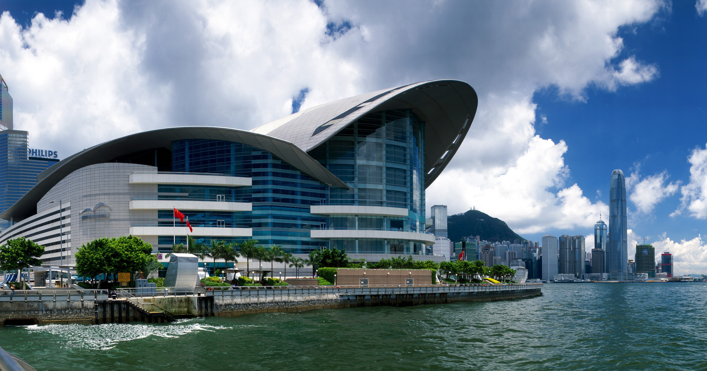 | Itinerary:-  Day 01. Meet and transfer to hotel to check-in  Day 02. After outside BF, start Non-Compulsory city tour,  visit The Stars Avenue, Aberdeen Fishing Village, Mid-levels of Victoria Peak,  Jewelry shop & outlet store.  Day 03. After outside BF, for 3D2N package, transfers to airport.  For 4D3N package, enjoy whole day free time.  Day 04. After outside BF, transfer to airport for departure.  Note: No outside BF for hotels in Hong Kong side.  City tours ends at Tsimshatsui, no transfer back to hotel.  ** RATES ARE NETT & NON- COMMISSIONABLE **
Choice of Hotels | Valid Period |  | 3D2N  Code: P-FE32 | 4D3N  Code: P-FE43 | Room Extension(NO BF)  Per Room Per Night
Kowloon & HK-Side | JAN – MAY 2012 | Twin/X-Bed |  | Twin/X-Bed | Twin/Sgl | X-Bed | BBF
Rambler Hotel | 01-21Jan, 29Jan-15Mar  16Mar-09Apr  22-28Jan, 10Apr-05May | 108  128  148 |  | 138  148  188 | 103  118  128 | N/A | 13
Silka Far East  (Hotel buffet BF included) | 01-21Jan, 29Jan-15Mar  16Mar-09Apr  22-28Jan, 10Apr-05May | 128  150  180 |  | 165  190  228 | 128  140  160 | 40 | 13
Silka Seaview  Silka West Kowloon  (Both hotel Incl htl. BBF) | 01-21Jan, 29Jan-15Mar  16Mar-09Apr  22-28Jan, 10Apr-05May | 148  170  190 |  | 198  220  270 | 138  160  180 | 40  N/A | 13  13
L’ Hotel Nina  Largos Hotel  (Incl hotel BBF)  Harbour Plaza 8D | 01-21Jan, 29Jan-15Mar  16Mar-09Apr  22-28Jan, 10Apr-05May | 150  180  208 |  | 208  230  280 | 140  160  198 | 55  N/A  55 | 19  13  16
Kimberley 4*  Eaton Hotel  L’ Hotel Causeway Bay | 01-21Jan, 29Jan-15Mar  16Mar-09Apr  22-28Jan, 10Apr-05May | 168  195  230 |  | 210  268  330 | 158  185  220 | 50  50  50 | 19  19  19
Regal Kowloon Hotel  Panorama Hotel  Royal Pacific Hotel-Wing | 01-21Jan, 29Jan-15Mar  16Mar- 09Apr  22-28Jan, 10Apr-05May | 180  210  240 |  | 230  300  340 | 170  190  240 | 65  65  N/A | 21  21  21

Only above hotels required to add Friday & Saturday Surcharge: USD20 Per Room per Night based on twin
16
16
Only above hotels required to add Friday & Saturday Surcharge : USD15 Per Room Per Night
16
16
Only above hotels required to add Friday & Saturday Surcharge : USD15 Per Room Per Night

Royal Garden / Mira hotel  Park Lane Hotel  Langham Place Hotel  Holiday Inn G. M.  M. Polo Gateway/ Prince  Royal Pacific Hotel- Tower | 01-21Jan, 29Jan-15Mar  16Mar-09Apr  22-28Jan, 10Apr-05May | 250  270  350 | 330  360  480 | 240  260  340 | 70  70  75  75  75  75 | 27  25  27  27  27  23

Sneak-in Rate : | Per Child & Adult | 3D2N: US$50 per pax | 4D3N: USD55 per pax
Single Use = Twin Sharing Rate X 2 |  | Above rates are only for F.I.T., not for Group Bookings.
Remarks:
1. Upon arrival, please proceed to ‘Arrival Hall B, Tourist Pick Up Area, Meeting Post No. 15’ to look for Asian Links Holiday Representative for the transfer in service.

2. Our transfer services by seat in coach daily from airport to hotel start only from 9:30 am to 11:00 pm.

3. In the event of flight delay arriving after 11:00pm, passengers are required to make their own mode of transportation to the hotel.
After city tour, mandatory tipping of HKD50 per pax for tour guide & driver will be collected.

NOTE: SURCHARGE OF $35/pax/way for early or late arrival/departure from 2230-0700hrs.

